ECE 579 Intelligent Systems, Fall 2024
Project Progress Report
Project title: Multimodal Data with Anomaly techniques for Object detection and tracking in Autonomous Driving.
Students in the project group:
Revathy Iswarya Sekaran (11625243): Data Preprocessing, Model Development, Project Presentation
Aksheya Kannan Subramanian (25502870): Model Development, Model Evaluation
Dharshani Anandkumar (82653870): Model Development, User Interface Development

- What Has Been Completed and Responsibilities
  - Data Acquisition:
Revathy Iswarya Sekaran successfully transferred the Waymo Open Dataset to Google Drive using Google Cloud’s gsutil tool for efficient data handling.
  - Data Parsing:
Revathy Iswarya Sekaran parsed the Waymo TFRecord files, ensuring data is correctly formatted for model training and evaluation.
  - Visualization:
    - Revathy Iswarya Sekaran developed a visualization function to display camera images with bounding box annotations.
    - She decoded and displayed JPEG images using TensorFlow for verification.
    - She integrated LiDAR point projections on camera images to align with detected objects.
    - She added an optional color-based range visualization to indicate object distances.
  - Technological Survey and Research:
- Dharshani Anandkumar conducted a comprehensive survey of relevant technologies and research, including studies on YOLO, multimodal fusion with LiDAR, and advancements in real-time object detection for autonomous driving.
- She also summarized findings to guide model selection, multimodal integration, and experimental design.
  - Model Building:
Revathy Iswarya Sekaran integrated YOLOv5 for 2D object detection, processing images from multiple TFRecord files and visualizing detection results and saved output detections for further analysis and model evaluation.
- What Needs to Be Done and Responsibilities
  - Model Optimization (Week 4-6): Fine-tune the YOLO model and begin training additional models (e.g., Faster R-CNN, 3D CNNs) to improve detection accuracy and efficiency in various scenarios.
Responsible: Aksheya Kannan Subramanian, Dharshani Anandkumar
  - System Integration (Week 7-8): Combine 2D and 3D object detection models into a unified real-time detection and tracking system.
Responsible: Dharshani Anandkumar
  - Final Testing and Validation (Week 9): Test the integrated system across different datasets and driving conditions to evaluate performance.
Responsible: Aksheya Kannan Subramanian, Dharshani Anandkumar
  - Report Writing and Presentation Preparation (Week 10): Complete the final report and prepare the project presentation.
Responsible: All team members
- Time Schedule
- Weeks 1-3: Data acquisition, preprocessing, baseline model training (completed)
- Weeks 4-6: Model optimization and additional model training
- Weeks 7-8: System integration for real-time performance
- Week 9: Final testing and validation on varied scenarios
- Week 10: Report writing and presentation preparation
- Project Description: In this project, we aim to develop a real-time detection and tracking system for autonomous driving using multimedia data, including camera images and LiDAR point clouds. The focus is on identifying and tracking vehicles, pedestrians, and other road users to enhance autonomous navigation safety and efficiency. Using the Waymo Open Dataset, we are employing models such as YOLO for 2D object detection, with planned extensions to 3D object detection using additional models like Faster R-CNN and 3D CNNs. This system will be evaluated for its accuracy, speed, and robustness across various conditions, including different lighting and weather.

  - Project Methodology Flow Chart
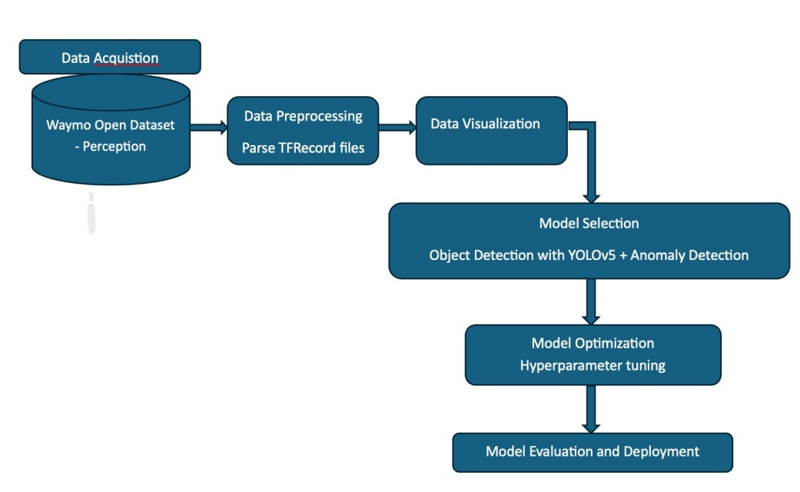

- Data Description: The primary data source is the Waymo Open Dataset, containing high-resolution LiDAR and camera data for autonomous vehicles. It includes over 1.2 million images and LiDAR observations with object labels for vehicles and pedestrians. This dataset supports multi-sensor data fusion, essential for accurate 3D object shape reconstruction and tracking.
- Proposed/Modified Method: The project involves using YOLOv5 for 2D object detection as a baseline model, with planned extensions to 3D detection using Faster R-CNN and 3D CNNs. Visualization functions and data parsing ensure that the data is correctly processed and visualized, while multimodal integration with LiDAR enhances depth perception and object alignment. We aim to optimize and evaluate these models based on accuracy, detection speed, and robustness.
- Experiment Design/ Case Study: The system will be evaluated through a series of experiments focusing on real-time detection accuracy, robustness in adverse conditions, and computational efficiency. Metrics such as precision, recall, and frame rate will be used to measure the system's effectiveness. Performance will also be compared across different scenarios, including varied lighting conditions and complex traffic environments.

